Linux Shells

Introduction to Linux Shells
As regular users of operating systems, we all extensively use the Graphical User Interface (GUI) to carry out most operations. It takes a few clicks on different options, and your task is done. However, you can perform almost every task by writing commands in the CLI of your operating system rather than using the GUI. The shells give you some great features for the commands you write in your CLI. This way of interacting with the OS is more efficient and resource-friendly.

Types of Linux Shells
echo command
- To see which shell you are using.
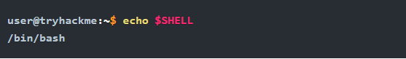

cat /etc/shells
- The file /etc/shells contains all the installed shells on a Linux system.
- List down the available shells in your Linux OS.
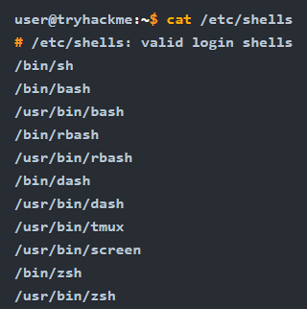

zsh
- To switch between these shells, you can type the shell name that is present on your OS, and it will open for you
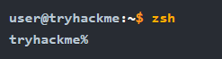

chsh -s /usr/bin/zsh
- To permanently change your default shell.

exit 0
- Quit current shell.

There are many types of Linux shells. We will discuss a few of them and their features.

- Bourne Again Shell (Bash): Default in most Linux distributions, with powerful scripting capabilities and features like command history and tab completion.
- Friendly Interactive Shell (Fish): Focuses on ease of use with auto spell correction, customizable themes, and syntax highlighting.
- Z Shell (Zsh): Known for its extensive customization options and advanced tab completion features, but may run slightly slower due to its many features.

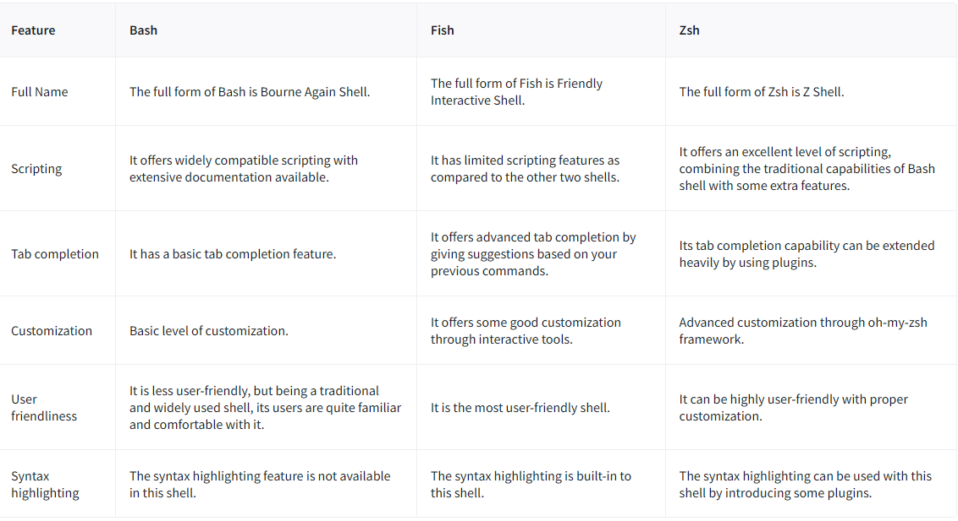

Shell Scripting and Components
Shell scripting allows users to automate repetitive tasks by combining several commands into a single executable file, which can be run at once. A basic shell script includes several key components:

Create script file
- create a file using any text editor for the script.
- The file must be named with an extension .sh, the default extension for bash scripts.

Shebang (#!): Defines the interpreter used to run the script (e.g., #!/bin/bash for Bash).

- Variables: Allow storing values that can be used throughout the script.
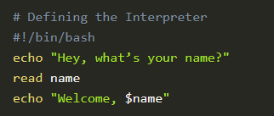
echo - displays on screen
read - take input from the user
name - variable in which the input would be stored.

save the script by pressing CTRL+X. Confirm by pressing Y and then ENTER.

Execution permissions
- To execute the script, we first need to make sure that the script has execution permissions. To give these permissions to the script,
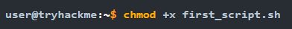

Execute the script
- Use ./ before the script name to execute it.
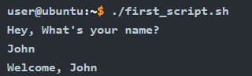
- Loops: Repeatedly execute a set of commands.
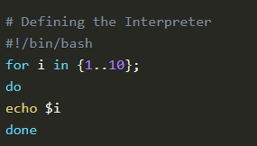
The first line has the variable i that will iterate from 1 to 10 and execute the below code every time. do indicates the start of the loop code, and done indicates the end. In between them, the code we want to execute in the loop is to be written. The for loop will take each number in the brackets and assign it to the variable i in each iteration. The echo $i will display this variable’s value every iteration.

Output:
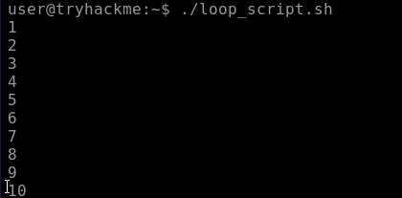

- Conditional Statements: Execute different code depending on certain conditions.
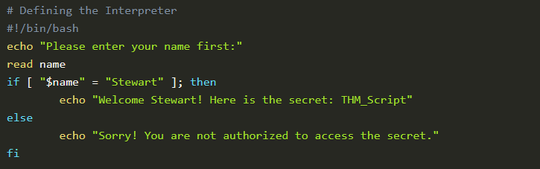
The above script takes the user’s name as input and stores it into a variable. The conditional statement starts with if and compares the value of that variable with the string Stewart; if it’s a match, it will display the secret to the user, or else it will not. The fi is used to end the condition.

Output:
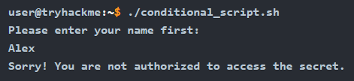

Comments
- To write a note for your understanding of the code you wrote.
- Use # following with your notes.
Exercise
In the previous task, we studied variables, loops, and conditional statements in shell scripting. Let’s use that knowledge to create a shell script that utilizes all these components.

Requirement
A user has a locker in a bank. To secure the locker, we have to have a script in place that verifies the user before opening it. When executed, the script should ask the user for their name, company name, and PIN. If the user enters the following details, they should be allowed to enter, or else they should be denied access.

Username: John
Company name: Tryhackme
PIN: 7385

Script
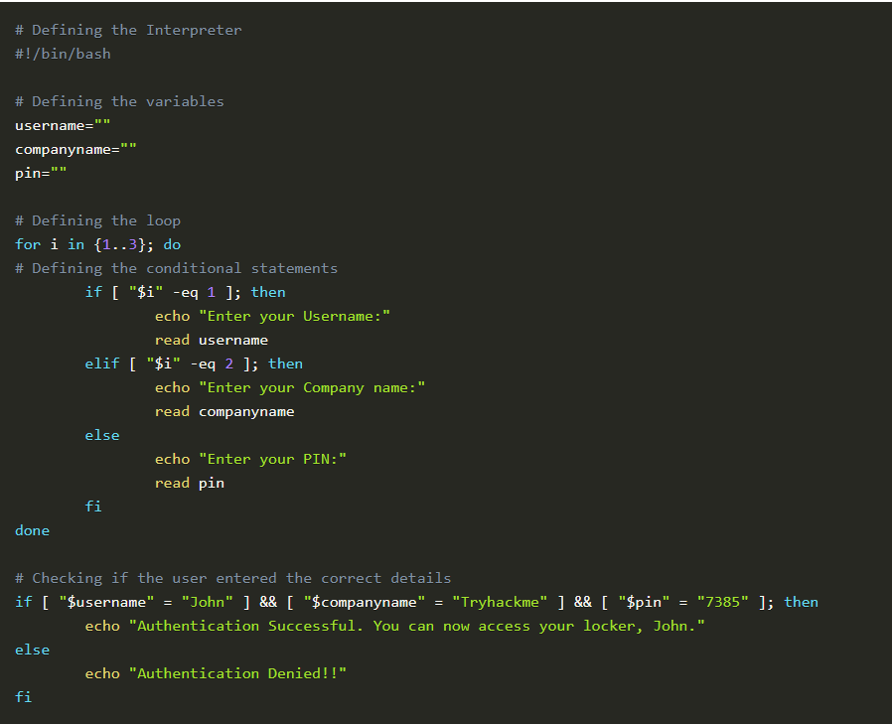

Script execution
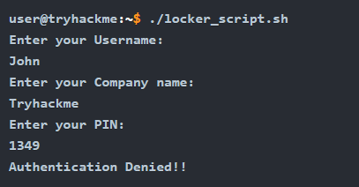
Become Root User
sudo su

